
1.Since there are 6.6 million rows in the data set, all 6 ( Melissa too) of us can each run a million to further verify or explore as well, effectively breaking down the set in parts and then comparing notes, going forward, if needed!

2. "Top 10" list. This list is balanced across the three data systems (Hawkins, Kinexon, Vald) ³ and has extremely high relevance to the physiology and sports medicine of Football, Basketball, and Lacrosse./ Gemini ( all of our sources/findings from datasets to get the big picture )
We can decide on any 5 among the top 10 that everyone has been finding repeatedly, comparing Briggs,Naira’s, Sid’s, Paul’s and mine. Ran this script again. Still continuing the exploration…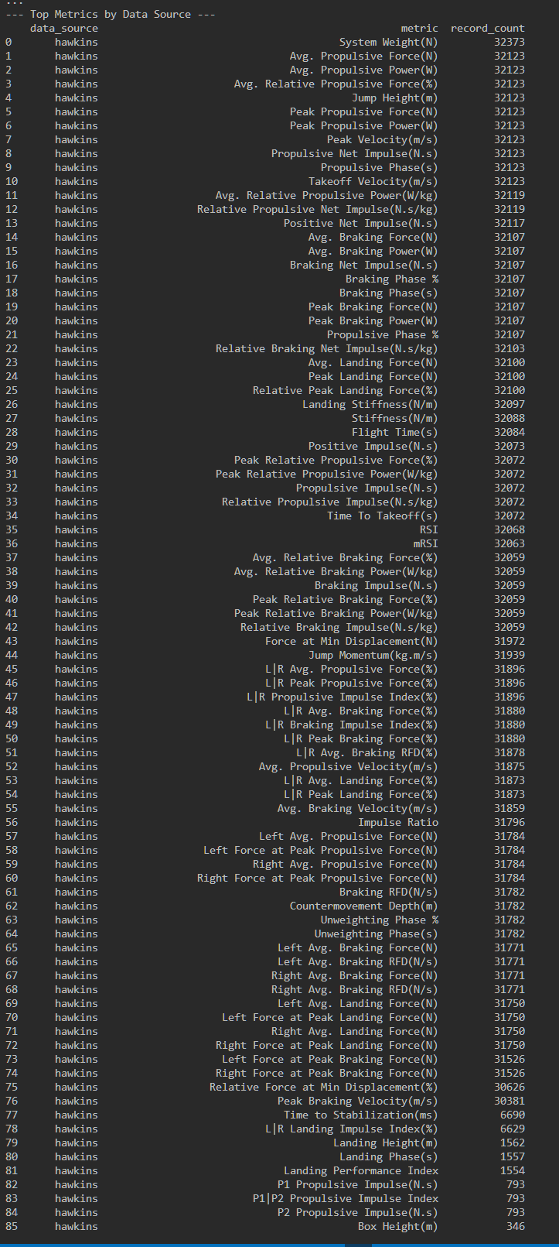 
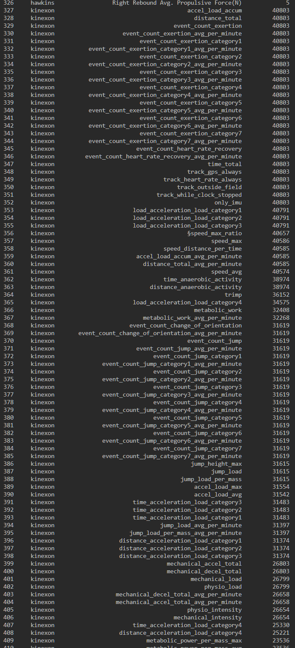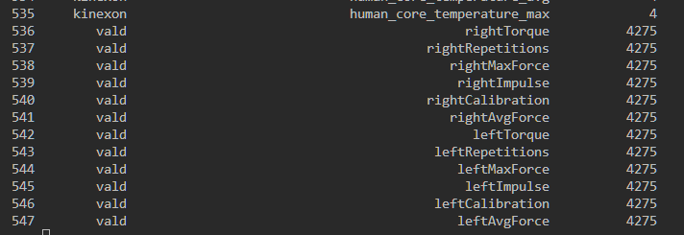

SPORTS MEDICINE ANALYSIS FROM OUR COMBINED METRICS EXPLORATION – underlined ones would be the best to be used !
Group 1: Hawkins Force Plate Metrics (Power & Injury Risk)
These metrics measure neuromuscular performance, power, and landing mechanics.
1. Avg. Jump Height (m) ⁴⁴⁴
- Relevance to Sports: This is a fundamental measure of lower-body explosive power. It's directly relevant for Basketball (rebounding, blocking), Football (receivers, linemen explosion), and Lacrosse (explosive first step).
- Sports Medicine & Physiology: It's a key performance indicator (KPI) of neuromuscular readiness. A sudden drop in jump height can be a primary physiological indicator of fatigue, which precedes many injuries. It's also a benchmark for return-to-play protocols.
2. Peak Propulsive Power (W) ⁵⁵⁵
- Relevance to Sports: Measures raw explosiveness⁶. This is the "horsepower" behind a sprint, a jump, or a tackle. It's critical for athletes in all three sports who need to overcome inertia quickly.
- Sports Medicine & Physiology: This metric is highly sensitive to training adaptation. From a medicine perspective, it helps quantify the functional recovery of the neuromuscular system after an injury or a heavy training block.
3. Peak Landing Force (N) ⁷⁷⁷
- Relevance to Sports: All three sports involve constant jumping and cutting (i.e., landing). This metric measures the impact the body sustains on every landing.
- Sports Medicine & Physiology: This is a critical injury risk metric⁸⁸⁸. High peak landing forces are strongly associated with increased stress on the patellar tendon, cartilage, and, most notably, the ACL⁹. This is a perfect metric for your Part 4 flagging system¹⁰.
4. Landing Stiffness (N/m) ¹¹
- Relevance to Sports: This measures an athlete's strategy for landing—are they landing "soft" (like a spring) or "stiff" (like a pogo stick)? Stiff landings are faster but riskier.
- Sports Medicine & Physiology: This is a key neuromotor metric¹². Athletes who are too stiff may have a higher risk of bone or cartilage injury, while athletes who aren't stiff enough may have a higher risk of ligament injury (like the ACL)¹³. It provides insight into an athlete's motor control strategy.
5. Braking Net Impulse (N·s) ¹⁴¹⁴
- Relevance to Sports: Measures the total force absorbed during a landing or braking task¹⁵¹⁵. This is vital for change-of-direction speed, a skill that defines elite Football and Lacrosse players.
- Sports Medicine & Physiology: This quantifies an athlete's ability to decelerate. Poor deceleration mechanics (low impulse absorption) mean that braking forces are transferred to passive structures (ligaments/joints) instead of being controlled by muscles (eccentric strength), significantly increasing injury risk.

Group 2: Kinexon GPS/Accelerometry Metrics (External Load & Fatigue)
These metrics measure what the athlete actually did on the field or court.
6. Max. Acceleration (m/s²) ¹⁶¹⁶¹⁶
- Relevance to Sports: Measures the ability to get to top speed. This is crucial for Football receivers beating a corner, Lacrosse midfielders clearing the ball, and Basketball players on a fast break.
- Sports Medicine & Physiology: High acceleration events are physiologically very demanding and place significant stress on soft tissues (e.g., hamstrings, groins). Tracking this helps manage the load to prevent muscle strains.
7. Avg. Braking Velocity (m/s) (or Deceleration) ¹⁷¹⁷¹⁷
- Relevance to Sports: This is the opposite of acceleration. How fast can an athlete "put on the brakes"? This is arguably more important than acceleration for court/field sports.
- Sports Medicine & Physiology: Decelerations are known to cause significantly more muscle damage (eccentric loading) than accelerations. A high number of intense braking events is a major red flag for fatigue and a precursor to non-contact injuries.
8. Sprint Count ¹⁸
- Relevance to Sports: A simple, powerful measure of total high-intensity work. How many times did the athlete perform an all-out sprint?
- Sports Medicine & Physiology: This is a classic "external load" metric. A sudden spike in weekly sprint count (e.g., 50 sprints this week vs. a 20-sprint average) is one of the most reliable predictors of an upcoming injury. This is a perfect "flag" for your Part 4 analysis¹⁹.
9. event_count_exertion_category4 ²⁰
- Relevance to Sports: This is a composite "high-intensity" metric. It counts the total number of very hard efforts, which could be sprints, jumps, or hard cuts.
- Sports Medicine & Physiology: This is an excellent metric for monitoring cumulative fatigue²¹. While one hard practice is fine, a high count of these events over several days indicates an athlete may be in an "over-reached" or "over-trained" state, suppressing their immune system and increasing injury risk.

Group 3: Vald Strength Metric (Imbalance & Readiness)
This metric measures underlying strength and potential asymmetries.
10. Asymmetry (%) ²²
- Relevance to Sports: All three sports are "asymmetrical" (e.g., cutting off one leg, shooting a basketball with one dominant arm/opposite leg). This metric quantifies the strength or power difference between the left and right sides.
- Sports Medicine & Physiology: This is a cornerstone of modern sports medicine. An asymmetry (e.g., in hamstring strength or jump height) greater than 10-15% is a major, validated risk factor for re-injury (especially ACLs and hamstrings). It's the #1 metric used in return-to-play decisions²³.
By selecting metrics from these three groups, you get a complete picture:
- Vald: What is the athlete's baseline strength?
- Hawkins: How well can they express that strength as power?
- Kinexon: How are they using that power on the field, and what is the cumulative load?

